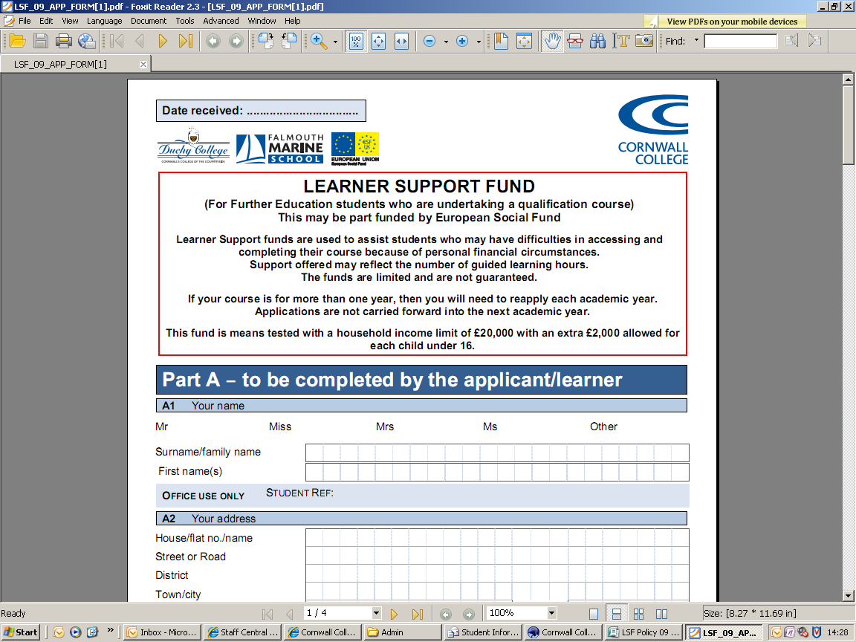

**APPLICATION FOR FINANCIAL HELP TOWARDS CHILDCARE COSTS**

(For Further Education students who are undertaking a qualification course)

This may be part funded by European Social Fund

**PLEASE ENSURE YOU READ THIS APPLICATION FORM CAREFULLY**

|  |
| --- |
| **If you are under 20 years old, do not complete this application form as you must apply to Care to Learn – 0800 121 8989** [**www.direct.gov.uk/caretolearn**](http://www.direct.gov.uk/caretolearn) **or ask at Student Services.**  **Free Early Education Places**  **Parents of all 3 and 4 year olds, and some 2 year olds, are entitled to up to 15 hours per week of free early education for their child(ren), which should be accessed through your childcare provider, before applying for funding from the Learner Support Fund (LSF). You may apply for LSF to cover any extra hours, over and above your free entitlement, necessary to complete your course.**  **For example: If your child has a free early education place at a nursery for 12.5 hours per week but you need childcare for 28 hours to attend your learning and complete your course, you can only claim 15.5 hours of childcare from LSF**  **If your child becomes entitled to any free early education at any time during this academic year, please inform your childcare provider and Student Services.** |

Please note that payments will be made monthly directly to childcare providers. Please ask your childcare provider to send their invoice to Student Services, clearly stating your name as well as your child/children’s full name(s). Hours/times being claimed for will also need to be clearly outlined on the invoice.

Your attendance will be monitored. Failure to demonstrate continued, regular attendance will mean that future childcare support will be suspended. Should you withdraw from your course, then please inform Student Services. Your support will cease immediately and you will be liable for extra payments incurred.

Please note that support will be considered only for registered childcare. Informal childcare (e.g. provided by a relative) cannot be supported.

Only children aged 14 or under (18 or under if the child is disabled) can be supported.

|  |
| --- |
| **Please complete a separate application for each Childcare provider** |

**MAXIMUM PAYMENT OF UP TO £125.00 PER WEEK**

**WITH A LIMIT OF £4,000 PER ACADEMIC YEAR FOR EACH CHILD**

Please note:

* Payment is for time-tabled tuition hours only for the current academic year.
* Please check that there are no price increases intended for the forthcoming year. A reassessment cannot be made.
* If you decide to change providers the College will not pay notice given to your childcare provider. This cost will have to be met by the student.
* Notice is paid one month from the students confirmed leaving date. Students will be responsible for any additional costs.
* Childcare assessments may be subject to change once your timetable has been confirmed. If the stated hours on your form are more than your confirmed timetabled hours your childcare allocation will be reduced accordingly.

**Please do not assume childcare will be paid until you receive a letter stating how much support has been allocated to you.**

|  |
| --- |
| **D1 Applicant to Complete** |
| Name:   |  |  |  |  |  |  |  |  |  |  |  |  |  |  |  |  |  |  |  |  |  |  |  |  | | --- | --- | --- | --- | --- | --- | --- | --- | --- | --- | --- | --- | --- | --- | --- | --- | --- | --- | --- | --- | --- | --- | --- | --- | |  |  |  |  |  |  |  |  |  |  |  |  |  |  |  |  |  |  |  |  |  |  |  |  |   Date of Birth: (dd/mm/yyyy) |
|  |
| **STUDENT REF** …………………………………………………………………. (This is shown on your offer letter) |

|  |
| --- |
| **E1 Childcare Provider Details** |

|  |  |  |  |  |  |  |  |  |  |  |  |  |  |  |  |  |  |  |  |  |  |  |  |
| --- | --- | --- | --- | --- | --- | --- | --- | --- | --- | --- | --- | --- | --- | --- | --- | --- | --- | --- | --- | --- | --- | --- | --- |
|  |  |  |  |  |  |  |  |  |  |  |  |  |  |  |  |  |  |  |  |  |  |  |  |
|  |  |  |  |  |  |  |  |  |  |  |  |  |  |  |  |  |  |  |  |  |  |  |  |
|  |  |  |  |  |  |  |  |  |  |  |  |  |  |  |  |  |  |  |  |  |  |  |  |
|  |  |  |  |  |  |  |  |  |  |  |  |  |  |  |  |  |  |  |  |  |  |  |  |
|  |  |  |  |  |  |  |  |  |  |  |  |  | Postcode | | | |  |  |  |  |  |  |  |

Name:

House No/Name:

Street Name:

Town:

City/County:

|  |  |  |  |  |  |  |  |  |  |  |  |  |  |  |  |  |  |  |  |  |
| --- | --- | --- | --- | --- | --- | --- | --- | --- | --- | --- | --- | --- | --- | --- | --- | --- | --- | --- | --- | --- |
|  |  |  |  |  |  |  |  |  |  |  |  |  |  |  |  |  |  |  |  |  |

Main Tel. No.:

|  |  |  |  |  |  |  |  |  |  |  |  |  |  |  |  |  |  |
| --- | --- | --- | --- | --- | --- | --- | --- | --- | --- | --- | --- | --- | --- | --- | --- | --- | --- |
|  |  |  |  |  |  |  |  |  |  |  |  |  |  |  |  |  |  |

**Childcare Ofsted Registration Number** (please enclose a photocopy of your Ofsted certificate)

What best describes the care that this application covers? Is it at:

□ Out of School Club □ Childminder □ Day Nursery □Crèche

Name of contact who can confirm the child(ren)’s attendance:

|  |  |  |  |  |  |  |  |  |  |  |  |  |  |  |  |  |  |  |  |  |  |  |  |
| --- | --- | --- | --- | --- | --- | --- | --- | --- | --- | --- | --- | --- | --- | --- | --- | --- | --- | --- | --- | --- | --- | --- | --- |
|  |  |  |  |  |  |  |  |  |  |  |  |  |  |  |  |  |  |  |  |  |  |  |  |

First Name:

|  |  |  |  |  |  |  |  |  |  |  |  |  |  |  |  |  |  |  |  |  |  |  |  |
| --- | --- | --- | --- | --- | --- | --- | --- | --- | --- | --- | --- | --- | --- | --- | --- | --- | --- | --- | --- | --- | --- | --- | --- |
|  |  |  |  |  |  |  |  |  |  |  |  |  |  |  |  |  |  |  |  |  |  |  |  |

Surname:

|  |  |  |  |  |  |  |  |  |  |  |  |  |  |  |  |  |  |  |  |  |  |  |  |
| --- | --- | --- | --- | --- | --- | --- | --- | --- | --- | --- | --- | --- | --- | --- | --- | --- | --- | --- | --- | --- | --- | --- | --- |
|  |  |  |  |  |  |  |  |  |  |  |  |  |  |  |  |  |  |  |  |  |  |  |  |

Telephone No.:

|  |  |  |  |  |  |  |  |  |  |  |  |  |  |  |  |  |  |  |  |  |  |  |  |
| --- | --- | --- | --- | --- | --- | --- | --- | --- | --- | --- | --- | --- | --- | --- | --- | --- | --- | --- | --- | --- | --- | --- | --- |
|  |  |  |  |  |  |  |  |  |  |  |  |  |  |  |  |  |  |  |  |  |  |  |  |

Mobile:

|  |  |  |  |  |  |  |  |  |  |  |  |  |  |  |  |  |  |  |  |  |  |  |  |
| --- | --- | --- | --- | --- | --- | --- | --- | --- | --- | --- | --- | --- | --- | --- | --- | --- | --- | --- | --- | --- | --- | --- | --- |
|  |  |  |  |  |  |  |  |  |  |  |  |  |  |  |  |  |  |  |  |  |  |  |  |
|  |  |  |  |  |  |  |  |  |  |  |  |  |  |  |  |  |  |  |  |  |  |  |  |

Email address:

|  |
| --- |
| **E2 Childcare Details** |

Child/Children’s Name(s) Date of Birth or date the baby is due (dd/mm/yyyy)

|  |  |  |  |  |  |  |  |
| --- | --- | --- | --- | --- | --- | --- | --- |
|  |  |  |  |  |  |  |  |

|  |  |  |  |  |  |  |  |  |  |  |  |  |  |  |
| --- | --- | --- | --- | --- | --- | --- | --- | --- | --- | --- | --- | --- | --- | --- |
| 1. |  |  |  |  |  |  |  |  |  |  |  |  |  |  |

|  |  |  |  |  |  |  |  |
| --- | --- | --- | --- | --- | --- | --- | --- |
|  |  |  |  |  |  |  |  |

|  |  |  |  |  |  |  |  |  |  |  |  |  |  |  |
| --- | --- | --- | --- | --- | --- | --- | --- | --- | --- | --- | --- | --- | --- | --- |
| 2. |  |  |  |  |  |  |  |  |  |  |  |  |  |  |

|  |  |  |  |  |  |  |  |  |  |  |  |  |  |  |
| --- | --- | --- | --- | --- | --- | --- | --- | --- | --- | --- | --- | --- | --- | --- |
| 3. |  |  |  |  |  |  |  |  |  |  |  |  |  |  |

|  |  |  |  |  |  |  |  |
| --- | --- | --- | --- | --- | --- | --- | --- |
|  |  |  |  |  |  |  |  |

|  |  |  |  |  |  |  |  |  |  |  |  |  |  |  |
| --- | --- | --- | --- | --- | --- | --- | --- | --- | --- | --- | --- | --- | --- | --- |
| 4. |  |  |  |  |  |  |  |  |  |  |  |  |  |  |

|  |  |  |  |  |  |  |  |
| --- | --- | --- | --- | --- | --- | --- | --- |
|  |  |  |  |  |  |  |  |

|  |  |  |
| --- | --- | --- |
| Childcare Dates | Start Date: (dd/mm/yyyy) | End Date: (dd/mm/yyyy) |
| Child 1 | |  |  |  |  |  |  |  |  | | --- | --- | --- | --- | --- | --- | --- | --- | |  |  |  |  |  |  |  |  | | |  |  |  |  |  |  |  |  | | --- | --- | --- | --- | --- | --- | --- | --- | |  |  |  |  |  |  |  |  | |
| Child 2 | |  |  |  |  |  |  |  |  | | --- | --- | --- | --- | --- | --- | --- | --- | |  |  |  |  |  |  |  |  | | |  |  |  |  |  |  |  |  | | --- | --- | --- | --- | --- | --- | --- | --- | |  |  |  |  |  |  |  |  | |
| Child 3 | |  |  |  |  |  |  |  |  | | --- | --- | --- | --- | --- | --- | --- | --- | |  |  |  |  |  |  |  |  | | |  |  |  |  |  |  |  |  | | --- | --- | --- | --- | --- | --- | --- | --- | |  |  |  |  |  |  |  |  | |
| Child 4 | |  |  |  |  |  |  |  |  | | --- | --- | --- | --- | --- | --- | --- | --- | |  |  |  |  |  |  |  |  | | |  |  |  |  |  |  |  |  | | --- | --- | --- | --- | --- | --- | --- | --- | |  |  |  |  |  |  |  |  | |

|  |
| --- |
| **Now please pass this form to your childcare provider to complete sections E3-E5** |

|  |
| --- |
| **E3 Eligibility** |

**🞏** The child(ren) named in section E2 is/are entitled to grant funded hours

**🞏** I am **not** receiving funding for this childcare from another source, e.g. Nursery Education Grant

|  |
| --- |
| **E4 Childcare Placement Details and Provider’s Fees** |

|  |  |  |  |  |  |  |
| --- | --- | --- | --- | --- | --- | --- |
| How much will you charge during term-time **per week** and per child? | | |  | How many hours and part hours per child, of childcare will you provide **each week**? | | |
| Child 1 | |  |  |  | | --- | --- | --- | |  |  |  |   **£** | |  |  | | --- | --- | |  |  | | Child 1 | |  |  | | --- | --- | |  |  | | |  |  | | --- | --- | |  |  | |
| Child 2 | |  |  |  | | --- | --- | --- | |  |  |  |   **£** | |  |  | | --- | --- | |  |  | | Child 2 | |  |  | | --- | --- | |  |  | | |  |  | | --- | --- | |  |  | |
| Child 3 | |  |  |  | | --- | --- | --- | |  |  |  |   **£** | |  |  | | --- | --- | |  |  | | Child 3 | |  |  | | --- | --- | |  |  | | |  |  | | --- | --- | |  |  | |
| Child 4 | |  |  |  | | --- | --- | --- | |  |  |  |   **£** | |  |  | | --- | --- | |  |  | |  | Child 4 | |  |  | | --- | --- | |  |  | | |  |  | | --- | --- | |  |  | |

What is your session/hourly* rate? £____________ (*please delete as appropriate)

|  |
| --- |
| **E5 Childcare Provider’s Declaration** |

I hereby certify that:

* I have agreed to provide childcare for the child(ren) in section E2 at the costs shown in section E4 of this form
* I understand that I need confirmation from Student Services that the application has been accepted and at what rate before payment can be made
* I am registered with Ofsted specifically to provide childcare and have attached a photocopy of my certificate to this application if a copy has not already been sent
* I will tell Student Services immediately if I am de-registered by Ofsted for any reason whatsoever
* These costs are being charged at the same rate of fees charged to other parents
* The parent is not already receiving funding for the childcare costs being claimed
* I will not make any additional charges to the parent unless these are agreed and funding is identified in advance
* I will inform Student Services promptly if I stop providing childcare for the child(ren) shown, if the childcare fees change, or I am aware that the parent is no longer attending College.
* I will inform Student Services promptly if the child(ren) do not attend for a period of two weeks without reason.

Signed: .................................................................................................. Date: ..........................................

(print in **block capitals**): ....................................................................

|  |
| --- |
| **Applicants, please check that you have...**  **X**  Checked all sections completed. Please note incomplete applications forms will be returned.  **X**  Completed an FE Bursary application form. |

|  |  |
| --- | --- |
| **Now send this fully completed application form and evidence without delay to ‘FE Bursary Fund Student Services’ on the appropriate campus:-** | |
| **Cornwall College Camborne** Trevenson Road Pool Redruth Cornwall TR15 3RD  **🕿 01209 616272/616224**  **Cornwall College St Austell** Tregonissey Road St Austell Cornwall PL25 4DJ  **🕿 01726 226404/226618**  **Cornwall College Newquay** Wildflower Lane Trenance Gardens Newquay Cornwall TR7 2LZ  **🕿 01637 857960**  **Cornwall College Saltash** Church Road Saltash Cornwall PL12 4AE  **🕿 01752 850253** | **Falmouth Marine School** Killigrew Street Falmouth Cornwall TR11 3QS  **🕿 01326 310302**  **Duchy College Rosewarne** Camborne Cornwall  TR14 0AB  **🕿 01209 722135**  **Duchy College Stoke Climsland** Stoke Climsland Callington Cornwall PL17 8PB  **🕿 01579 372227** |

**We recommend that you read the ‘Policy and Guidance for the distribution of FE Bursary’ which, together with additional application forms, is available to read or download from our website:** [**http://www.cornwall.ac.uk/studentfinance**](http://www.cornwall.ac.uk/studentfinance)

**These documents are also available from Student Services on each campus.** **If you need any help in completing this application form please contact Student Services where staff will be happy to assist you.**

**If you require this form in larger print, please contact Student Services**

**Office use only:**

**Application successful: Date………………**

**Application unsuccessful: Date ……………… Reason…………………………………………………..**